Quantifying Crop Safety and Efficacy when Tank Mixing Insecticides and Fungicides
Report Submitted to the Northwest Potato Consortium

PERSONNEL:
Tim Waters, Washington State University Extension, twaters@wsu.edu, 404 W Clark Ave, Pasco, WA 99301, 509 545-3511.
David Linnard Wheeler, Washington State University, Department of Plant Pathology, Pullman, WA. 99163. david.wheeler@wsu.edu, (215) 880 3024.

REPORTING PERIOD: March 1, 2020 – January 1, 2021 (2020 Growing Season)

ACCOMPLISHMENTS:
Eleven combinations of two insecticides and three fungicides were evaluated for control of aphids and early blight in potatoes. None of the mixes resulted in incompatible tank mixes or crop phytotoxicity. Beleaf insecticide tank mixed with Manzate, Luna Tranquility or Bravo fungicides was effective at reducing aphid populations, contrary to applications of Warrior insecticide with the same fungicides or applied alone. Application of Warrior insecticide alone negatively impacted plant health and decreased potato yield and quality compared to Beleaf and Manzate tank mix. Early blight disease severity was extremely variable amongst treatments and will be more thoroughly investigated in 2021. There is no evidence in these data of antagonistic impacts of tank mixing the fungicides and insecticides tested in 2020.
PROCEDURES:
Umatilla Russet potatoes were planted into a center pivot irrigated field at the WSU Commercial Vegetable Research Farm in Pasco on April 17, 2020. Each plot was four rows (34 inch) by twenty-five feet in length and treatments were replicated four times in a randomized complete block design. Prior to planting dry fertilizer (N: 58, P: 275, K: 200 and S: 30 lbs/A) was applied and incorporated with a disk, then hills were formed with hilling shovels. In addition, 40 lbs/A of nitrogen was added in season by five different applications via center pivot in the form of solution 32. This is a reduced amount compared to the other sections of potatoes at the farm to induce greater disease pressure by early blight (Alternaria solani). A two row manually assisted planter was used to place seed 8 inches deep and 11 inches apart down the row. At planting, Quadris F and Ridomil Gold were applied (8 and 6.5 fl oz/A respectively) in furrow. Prior to emergence, a mix of glyphosate, Prowl, Metriclude and Zidua (32 oz, 32 oz, .3 lb and 3.25 oz per acre respectively) was applied at 20 gallons of water per acre with broadcast application, then incorporated in with 0.33 inches of water for season long weed control. Colorado potato beetle was managed with Coragen, a selective insecticide that would not limit aphid populations via center pivot chemigation application. Ranman and Forum fungicide were also applied by center pivot chemigation to manage for late blight, but not influence early blight due to their narrow spectrum of fungicidal activity.
Treatments were applied twice (July 27 and August 10, 2020) in an effort to coincide with the onset of development of early blight symptoms and aphid infestation. The treatments (Table 1) were applied with a CO2 pressurized three-point tractor mounted plot sprayer. The sprayer utilizes multiple spray booms each equipped with seven 11002 T-Jet Air Induction nozzles. The products were applied at 20 gallons per acre with the sprayer pressure set at 25 psi and the tractor speed of 2.3 miles per hour.
Physical compatibility was rated in a simulated jar test. Each product was mixed at the appropriate rate for application at 20 gallons per acre in a clear three-liter plastic bottle. The mixes were scored as either compatible or incompatible for both applications of each product mix that was made.
Aphid efficacy was evaluated weekly by shaking five plants per plot over a one-gallon white bucket and counting the number of winged and wingless aphids per sample. This simulates a beating sheet and is equivalent to sampling approximately one entire plant.
Early blight severity was estimated weekly for six weeks beginning on July 1st. Each plot, comprised of four rows, was first inspected from the plot perimeter. Rows with early blight symptoms were then identified and inspected further by walking between the rows within the plot. Early blight severity was then estimated by approximating the percentage of plants within a plot that expressed symptoms.
To compare the effects of the treatments on early blight symptoms, all six early blight ratings were first used to calculate the area under the senescence progress curve (AUSPC). Differences between treatments were then detected with a one-way ANOVA. Post-hoc comparisons between treatments were completed with Tukey’s honestly significant difference (HSD). Assumptions for ANOVA were evaluated with plots and tests of normality and homoscedasticity.
Plots were irrigated as needed by center pivot, and on September 10, 2020, the potatoes were desiccated with Reglone herbicide. On September 28, 2020, harvest was done by taking a digger lifter through the middle two rows of each plot. A five-foot section of both rows was hand bagged, then taken to the WSU Othello Station, where on September 29, 2020 potatoes were graded and sorted to determine yield and grade.
Insecticide efficacy and yield and quality data were subjected to ANOVA and means separated using the Student-Newman-Keuls test (p=0.05).
Treatment | Insecticide | Fungicide
1 (UTC) | None | None
2 | Warrior (L-cyhalothrin) 1.92 fl oz/A | Manzate (mancozeb) 1.6 qt/A
3 | Warrior (L-cyhalothrin) 1.92 fl oz/A | None
4 | None | Manzate (mancozeb) 1.6 qt/A
5 | Beleaf (flonicamid) 2.8 oz/A | Luna Tranquility 16 fl oz/A (fluopyram+pyrimethalanil)
6 | Beleaf (flonicamid) 2.8 oz/A
7 |  | Luna Tranquility 16 fl oz/A (fluopyram+pyrimethalanil
8 | Beleaf (flonicamid) 2.8 oz/A | Bravo WS (chlorothalonil) .75 pt/A FB 1.5 pt/A
9 |  | Bravo WS (chlorothalonil) 75 pt/A FB 1.5 pt/A
10 | Warrior (L-cyhalothrin) 1.92 fl oz/A | Bravo WS (chlorothalonil) 75 pt/A FB 1.5 pt/A
11 | Beleaf (flonicamid) 2.8 oz/A | Manzate (mancozeb) 1.6 qt/A
12 | Warrior (L-cyhalothrin) 1.92 fl oz/A | Luna Tranquility 16 fl oz/A (fluopyram+pyrimethalanil)
Table 1. Product mixes tested. All products were applied twice at the same rate, except Bravo where the first application was 0.75 and second application was 1.5 pints per acre. All mixes included 0.25% non-ionic surfactant.

RESULTS/DISCUSSION:
In the simulated jar test, all mixes dissolved in solution and did not produce notable precipitates and therefore were all scored as compatible. This is not surprising since the tank mixes evaluated were recommended by crop advisors who routinely utilize these mixes in potato production, none the less it was important to confirm physical compatibility before further testing was done. No crop phytotoxicity was noted either.
Aphid populations were rather low at the beginning of the 2020 growing season. In fact, at the first application date, we only detected an average of one wingless aphid per plant. The first application had to be made in late July to keep early blight from overtaking the plot area. Fortunately, just after the second application aphid numbers increased dramatically in the experimental block. The second application (August 10) occurred just two days before the scheduled evaluation on August 12. Since the application was so close that evaluation date, we did not detect any differences in the aphid populations initially. However, by the following evaluation date (August 19) plots treated with Beleaf insecticide combined with any of the three fungicides contained fewer wingless aphids than the untreated check plots (Figure 1). Plots treated with any of the fungicides alone, or in mix with Warrior insecticide did not contain fewer aphids than the untreated check plots (Figure 1). Plots treated with Beleaf and Warrior alone did not significantly reduce aphid numbers compared to the untreated check (Figure 1). Warrior insecticide was ineffective at managing aphid populations, when applied alone, or in combination with Manzate, Luna Tranquility, or Bravo fungicides. Beleaf insecticide was effective at managing aphid populations when applied in a mix with Manzate, Luna Tranquility, or Bravo fungicides. In fact, the treatments in the trial with the fewest aphids were plots treated with any of the fungicides in combination with Beleaf insecticide, though not statistically significant. In terms of aphid control, these data do not demonstrate any antagonist impacts of tank mixing these combinations of insecticides and fungicides (Table 1).
Plant damage was assessed on August 26 by scoring test plots on a 0-10 scale where 0 would indicate no plant damage and a 10 would indicate the most severe plant damage attributed to insect feeding or disease lesions. Plots treated with Warrior insecticide alone contained significantly more plant damage than plots treated with Warrior+Manzate, Manzate, Beleaf+LunaTranquility, LunaTranquility, Beleaf+Bravo, Beleaf+Manzate, and Warrior+LunaTranquility (Figure 2). This gives an indication that Warrior and Beleaf alone and Bravo did not positively impact plant health.
Total yield, Market #1, Market #2, defects, and specific gravity did not differ among treatments (Data not shown). Market yield was significantly higher in plots treated with Beleaf+Manzate than plots treated with Warrior alone but did not differ between other treatments (Figure 3). Percent usable potatoes was significantly higher in plots treated with Warrior+Bravo compared to Warrior alone and did not differ between other treatments (Figure 4). The yield and grade data indicates strongly that Warrior alone does not improve, but rather may hinder yield and quality of potatoes.
Early blight symptoms were observed in plots from early July until harvest. Symptoms were variable between plots, within plots, and between treatments (Figure 5). For example, variability was relatively low for treatments 5 (Beleaf (flonicamid) 2.8 oz/A: Luna Tranquility 16 fl oz/A (fluopyram+pyrimethalanil) and 11 (Beleaf (flonicamid) 2.8 oz/A: Manzate (mancozeb) 1.6 qt/A) but relatively high for treatments 3 (Warrior (L-cyhalothrin) 1.92 fl oz/A) and 9 (Bravo WS (chlorothalonil) 75 pt/A FB 1.5 pt/A) (Figure 5). As a result of this variability, neither statistical nor practical differences in early blight disease symptoms were detected in this trial since p = 0.07 > α = 0.05 (Table 2).
To reduce this variability in the future, a more targeted approach to disease severity estimation will be used. More specifically, disease severity will be estimating by walking through the middle rows of the plots, exposing the canopy, and approximating the number of early blight lesions per plot. This approach has been used before by the primary PI and has yielded consistent results.

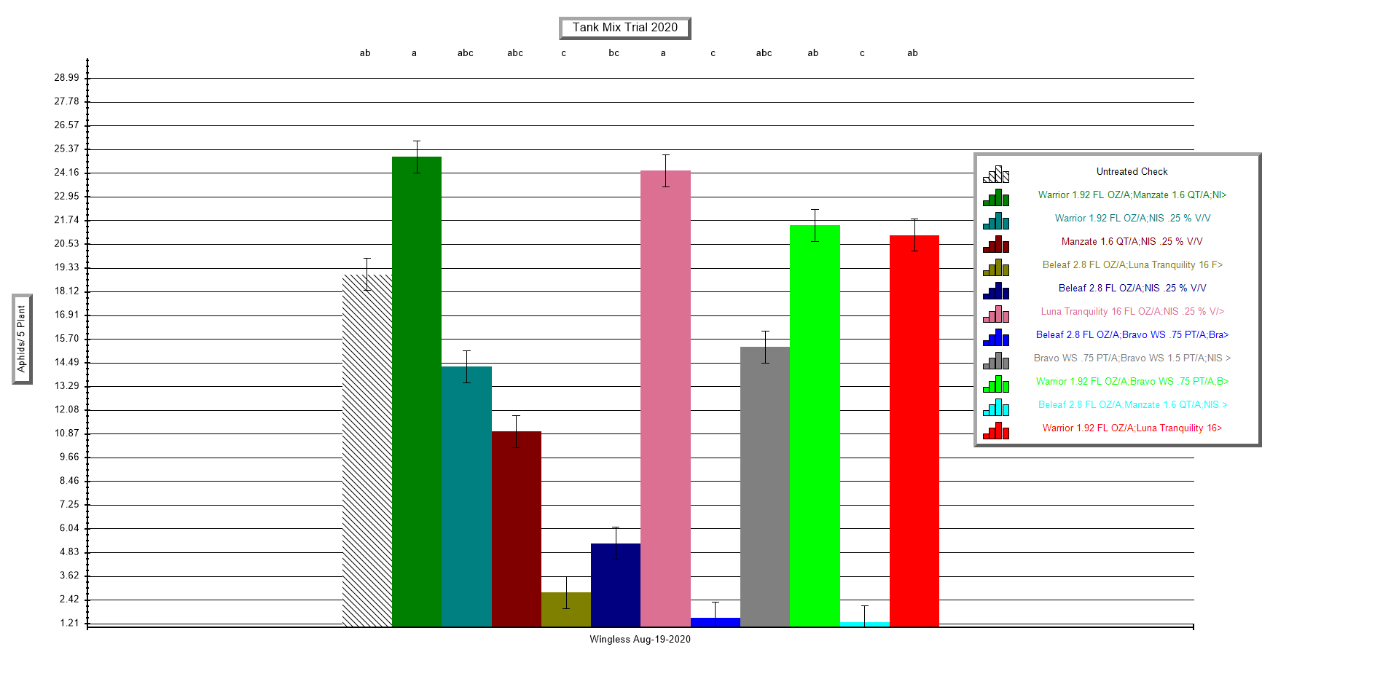
Figure 1. Aphids per plant by treatment using bucket sample assessment on August 19, 2020. Means followed by the same letter or symbol do not significantly differ (P=.05, Student-Newman-Keuls).
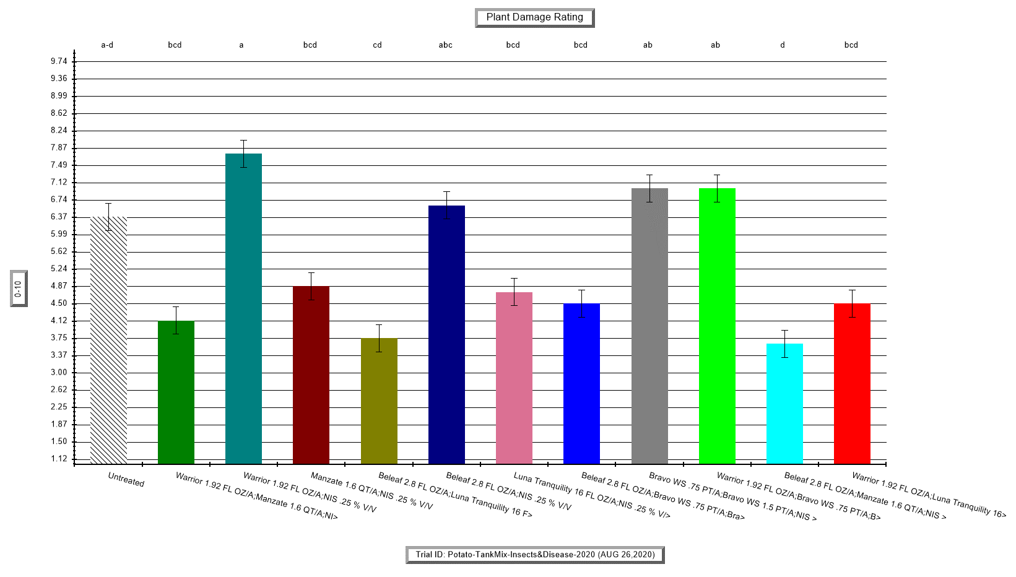
Figure 2. Plant damage assessments conducted on August 26, 2020. Scored on a 0-10 scale where 0 is no visible plant damage and 10 is 100% of the plants exhibiting damage. Means followed by same letter or symbol do not significantly differ (P=.05, Student-Newman-Keuls).

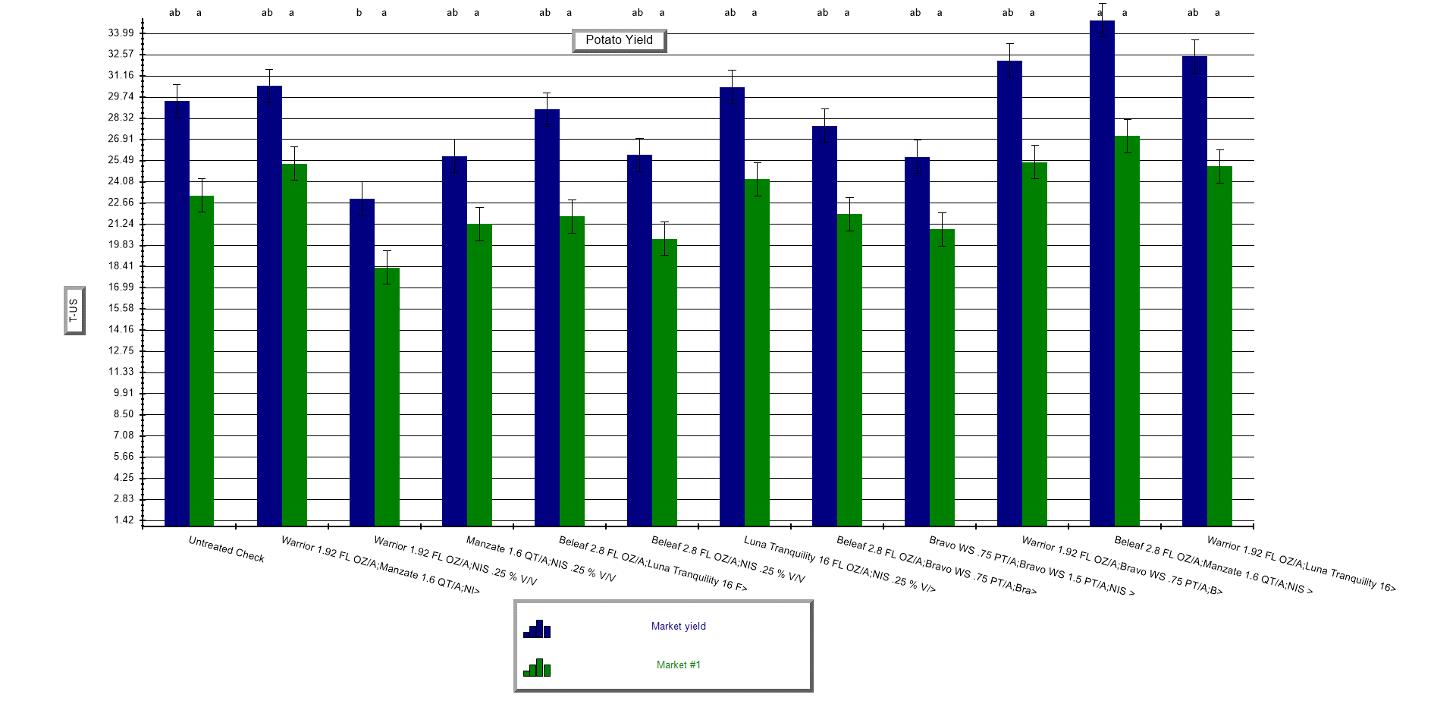
Figure 3. Market yield and Market #1 potato grades. Means followed by same letter or symbol do not significantly differ (P=.05, Student-Newman-Keuls).

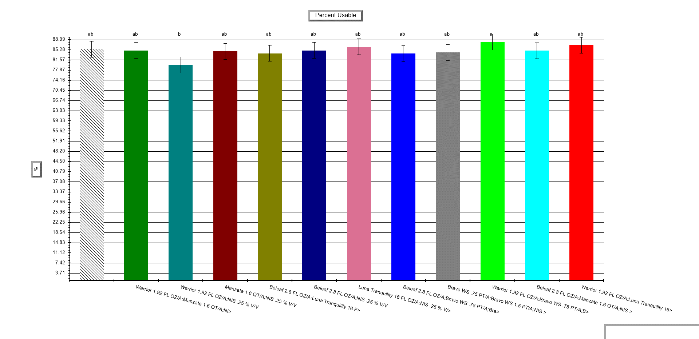
Figure 4. Percent usable potatoes. This is calculated by dividing the market yield by the total yield. Means followed by same letter or symbol do not significantly differ (P=.05, Student-Newman-Keuls).

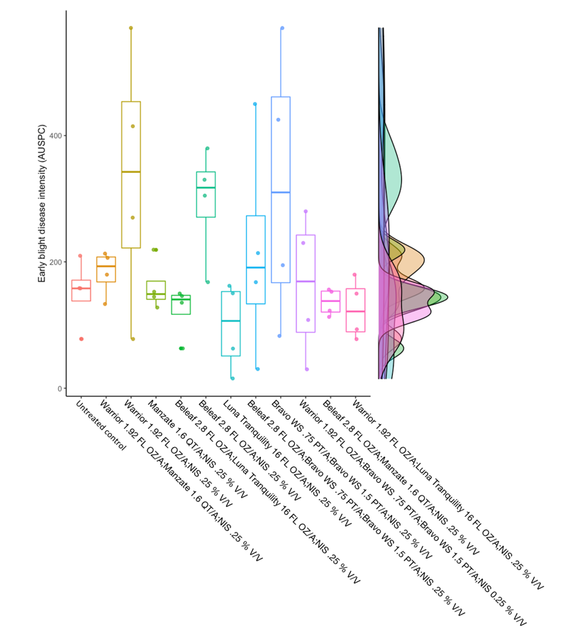
Figure 5. Early blight disease intensity, expressed as the area under the senescence progress curve (AUSPC). Higher values of AUSPC correspond to higher values of disease. Each point represents an observation from a block. Boxplots summarize the distribution of AUSPC values. The marginal histograms on the right axis summarize the distributions of all treatments.

Table 2. ANOVA table for early blight disease severity.
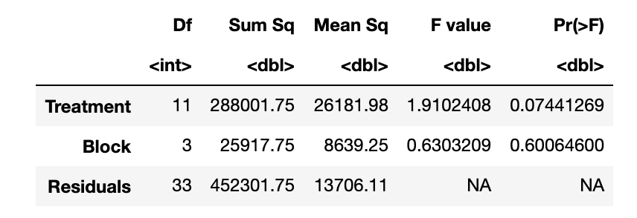
Publications:
None to date.
Presentations and Reports:
None to date.
Acknowledgements
This project was funded by the Northwest Potato Consortium. Technical and in-kind support was provided by numerous crop advisors, WSU Extension (Jennifer Darner, Jeffrey Lambert and Alexa Hintze).

